**Introduction:**

Twitter is one of the biggest social media platforms in the world , right now it's in the news because one of the greatest entrepreneurs of our times “ELON MUSK” recently took over twitter for a sum of 44 Billion United states dollars. One of the issues twitter has faced is how political discourse that happens on the website could lead to violence or physical harm. We are going to look at one such political discourse that happened on the site and try to analyze the historical data, and try to model it to maybe predict sentiments, check for bots etc.

Let’s talk a little bit about the topic that we will be working on. We are going to look at the tweets that were extracted during the political discourse around brexit. This dataset was collected from [Kaggle](https://www.kaggle.com/datasets/visalakshiiyer/twitter-data-brexit). This Twitter dataset covers the January - March 2022 period and comprises tweets relating to Brexit or Europe from Twitter accounts with publicly stated Brexit positions in their bio basically (anti or pro brexit positions). Now what is Brexit?, The United Kingdom was part of the European union until 2 years ago, when the then senate announced that the UK will no longer be a part of the European union. This led to a huge political discourse, some violent . A lot of the discussions regarding this took place on twitter.



[Image](https://www.dachser.us/en/mediaroom/Brexit-After-the-exit-is-before-the-exit-4170)

There are a total of 19 million people in the United Kingdom that use twitter, and it's really imperative for the government to monitor this platform to see how people are feeling about such a huge decision , in this case brexit. So the tweets pertaining to Brexit were extracted and we got a dataset of 300k rows, the tweets were also analyzed sentimentally i.e if a tweet had a positive or negative sentiment regarding brexit.

This data could help us analyze the tweets, and see how people feel about the decision. This also could help us analyze if the decisions are being manipulated by external factors such as some other country trying to run bots, and sway people’s decisions by taking advantage of the twitter dot com algorithm.

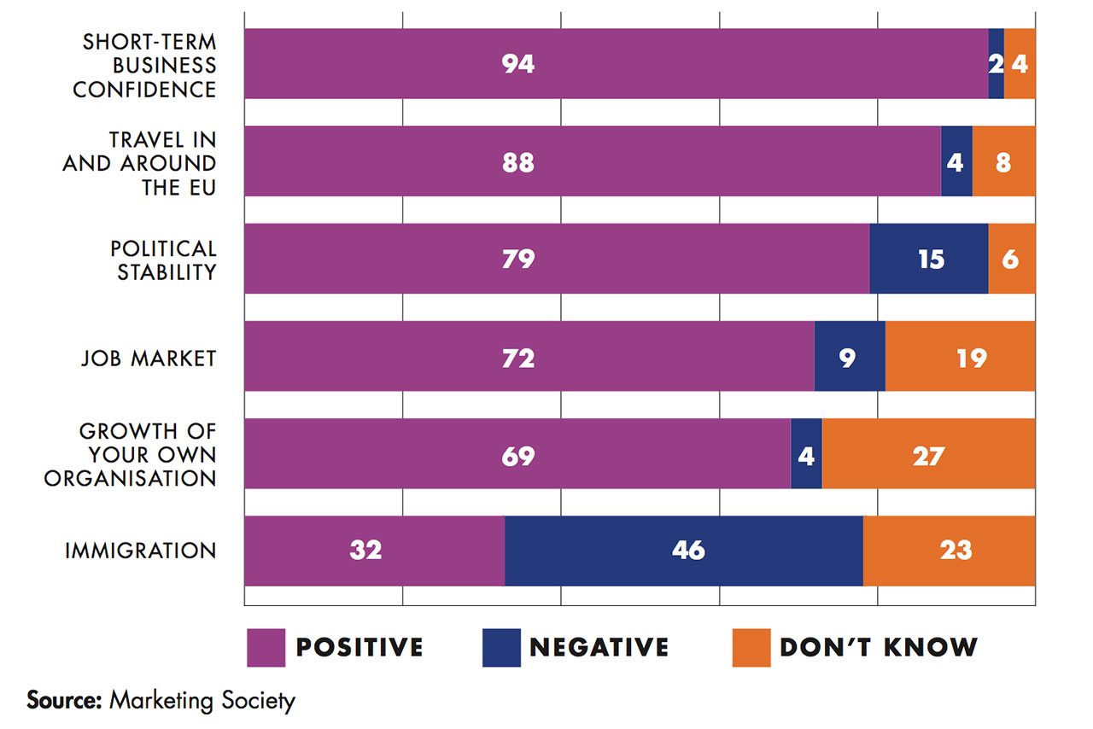

[Brexit Sentiment](https://www.campaignlive.co.uk/article/marketing-society-survey-reveals-anti-brexit-sentiment/1395259)

We will use this data to analyze the sentiment of the tweets, try to predict these sentiments, this could help us identify if tweets are harmful to a person in real life or not. Analyzing historical tweets like this could help avoid future harm, and also avoid bots that take advantage of the twitter algorithm that could sway people into committing crimes or making bad decisions. This is the aim of our project.

In this Project we will do various analyses of the data extracted and try to get useful information out of it. We will also use many machine learning algorithms supervised and unsupervised to do some predictive modeling on the dataset, we can use these models to tag harmful tweets and ban the respective people before the tweets go viral.Sentiment analysis on these tweets also could help analyze the sentiment of certain protests or decisions that affect the people. The government can then change its decision in a way that they can fulfill the needs of the majority of the people. This will help the authorities to maintain the sovereignty of the nation.

**Data Gathering:**

The Data Was Gathered using the OpenDatasets library in python, which basically is an easy interface to access the kaggle api to download the Open Datasets available in kaggle. All you have to do is download the package [OpenDatasets](https://pypi.org/project/opendatasets/). Then login into your Kaggle account and get access to your kaggle API credentials. Then Download the dataset using the link to the data and access the data on your local computer.

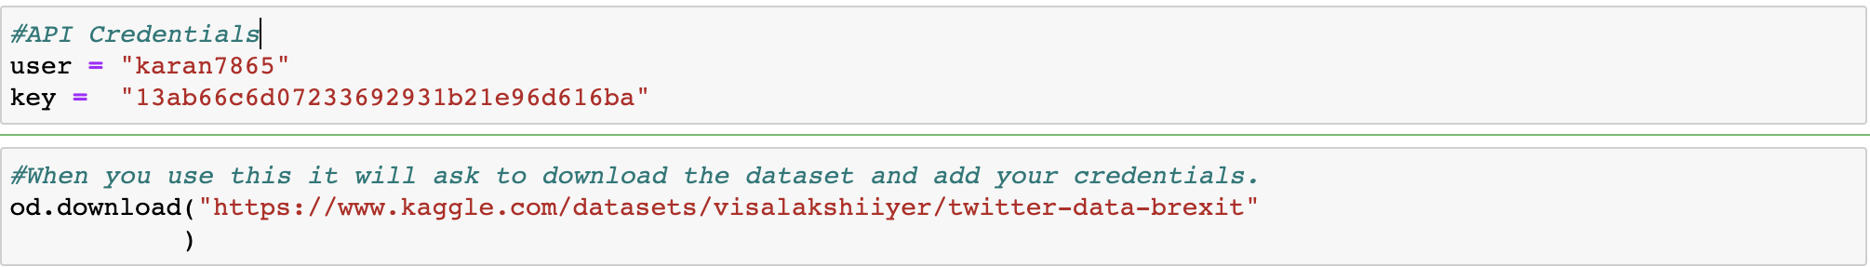

**Fig: How to use the Api.**

**Analysis**:

**Data Description:**

Date: The date the tweet was posted to Twitter.

URL: link to the tweet.

Hit Sentence: Tweet text.

Influencer: Account name for the user who shared the tweet.

Country: Country location of the Twitter account (if declared).

Subregion: Locale of the Twitter account (if declared).

Language: Automated language detection.

Reach: Estimate of the “reach” of the tweet, based on followers at the time of sending tweet.

Engagement: Sum of public engagements for the tweet (sum of likes, retweets and quote tweets).

Twitter Screen Name: Displayed name as appears on the Twitter profile of account.

User Profile Url: URL link to the Twitter account that shared the tweet.

Twitter Bio: Text from the Twitter bio section of the account.

Twitter Followers: Number of followers of the account.

Twitter Following: Number of accounts that are followed by this account.

Alternate Date Format: The date the tweet was posted to Twitter.

Time: The time the tweet was posted to.

This dataset has two files one csv file has anti brexit tweets and another has pro brexit tweets.

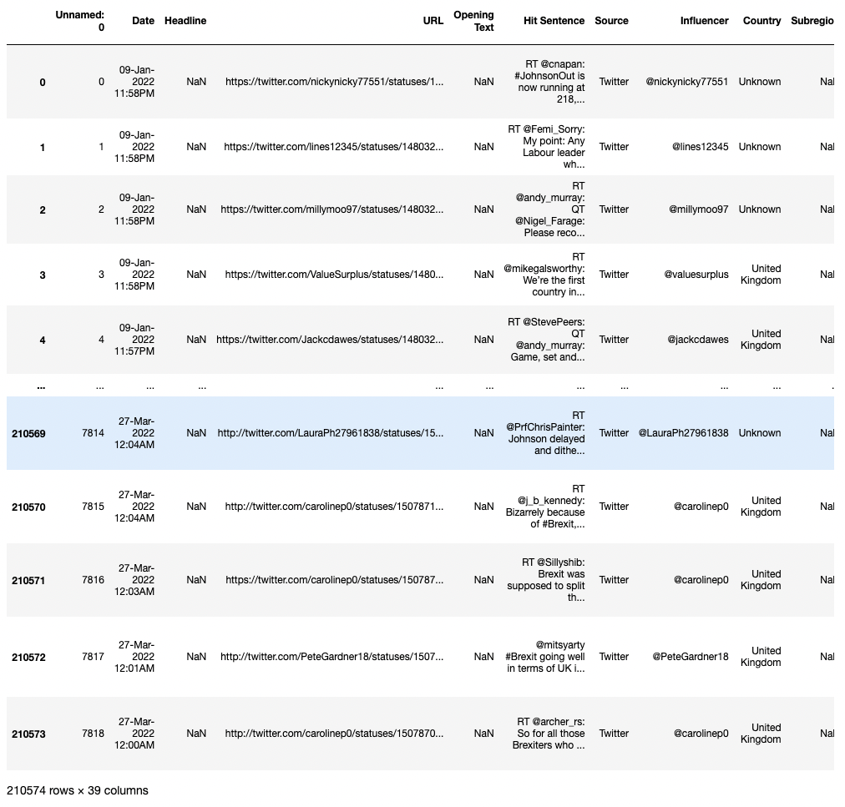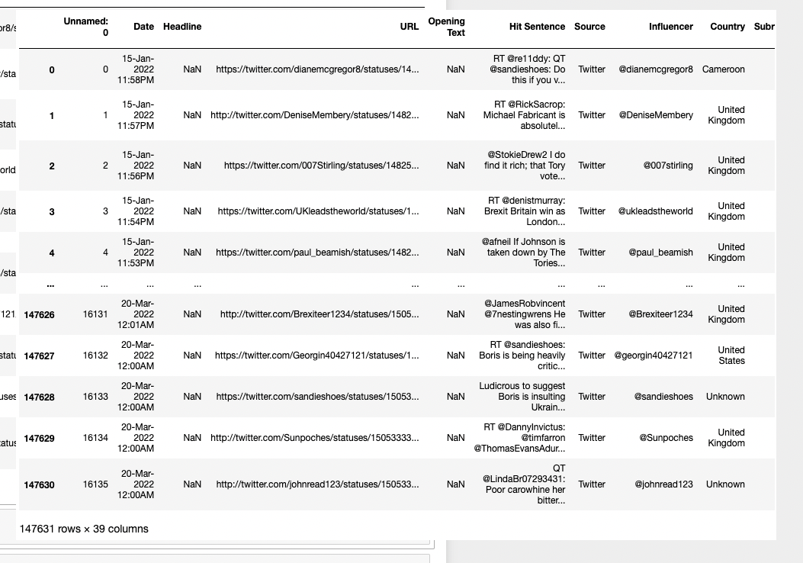

**Fig: Anti Brexit data** **Fig: Pro Brexit Data**

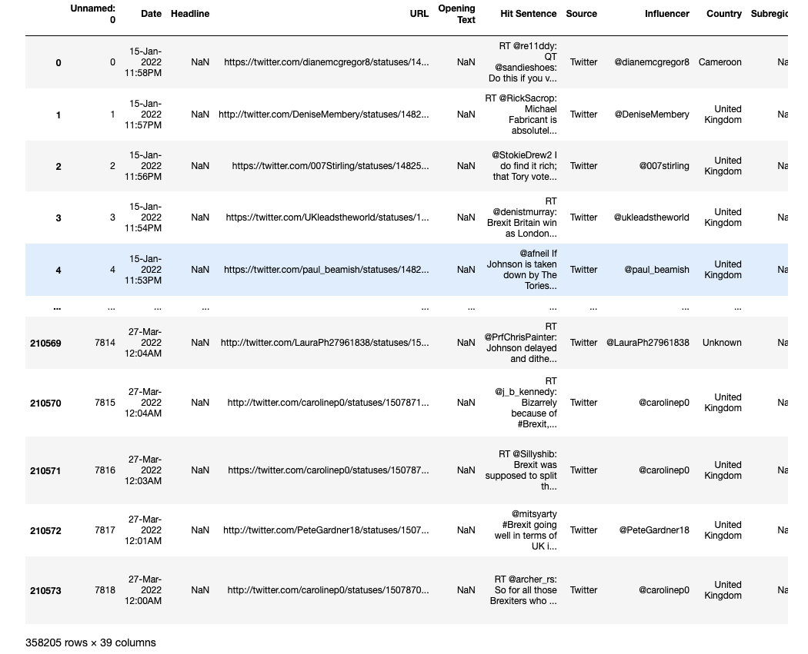

**Fig: Combined Anti+Pro data.**

**Basic Analysis:**

* We first check how many columns have what percent of unique values, now any columns with 100% unique values or 0% unique values should be dropped below code does exactly that.
* Then we check the null values and remove any column with more than 90% null values.
* Since the data was extracted from twitter we also need to preprocess all the text.

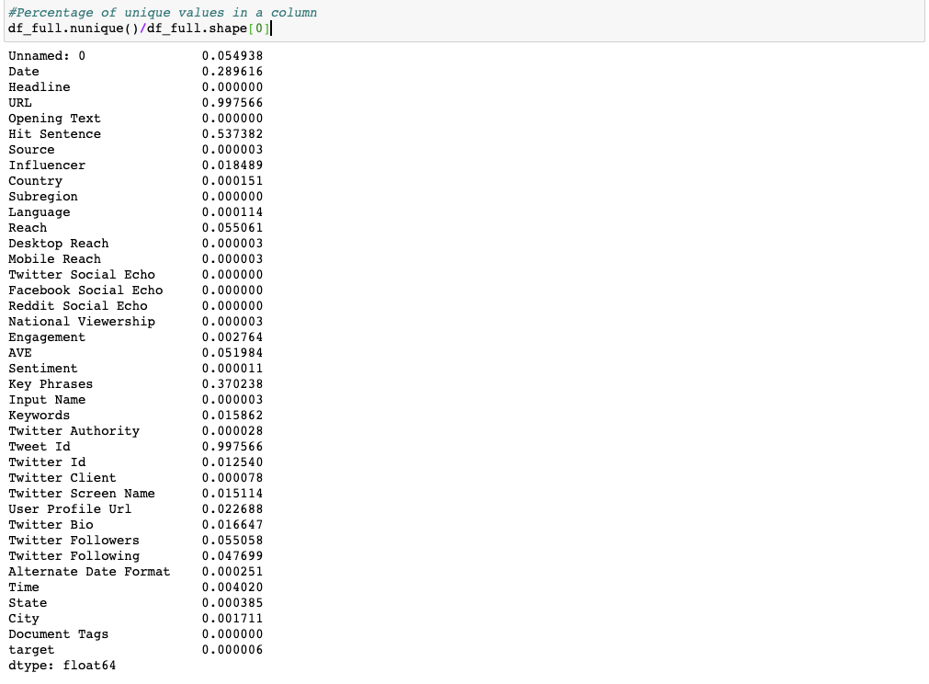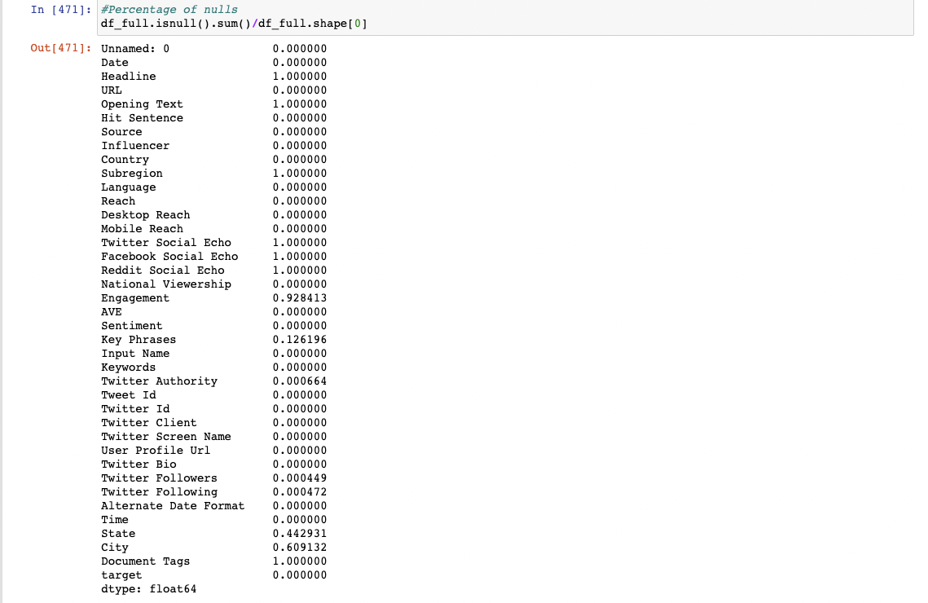

**Fig : Check Unique Values Fig: Check Null Values**

* The Function below preprocesses the text we want , and gives us the output of that text which we then use to do analysis.

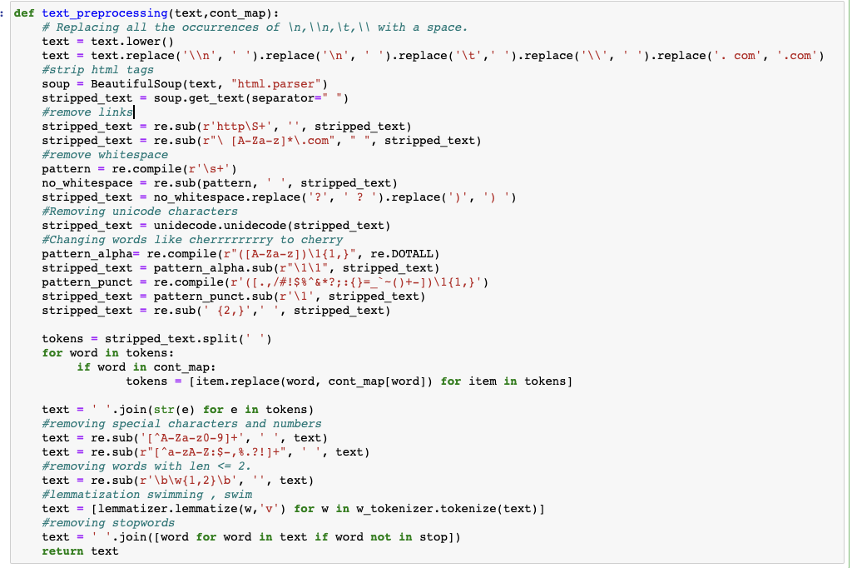

**Fig : Function to preprocess text data**

The Text analysis includes analysis on the Hit Sentence Column and Twitter Bio column.

* We do the analysis in two categories, i.e pro or anti brexit text, to see what are the top words used by both the groups.
* Check the Average word length used by them.
* Check the Top bigrams used .
* Check the Top trigrams used.

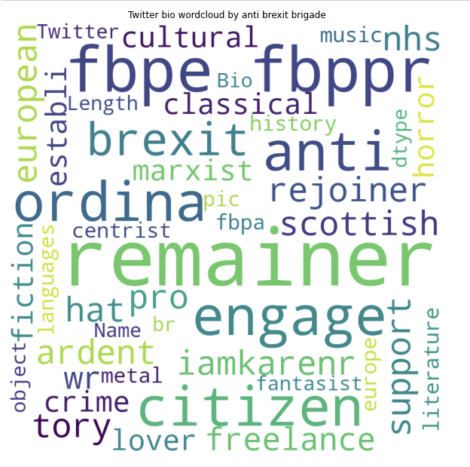

**Fig : Word Cloud**

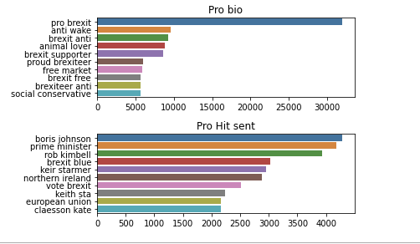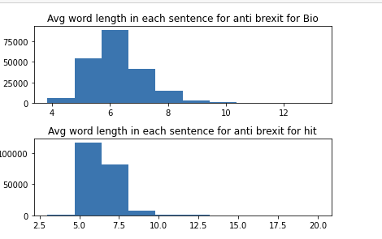

**Fig: Top Bigrams Fig: Avg Word length.**

**Analysis of Non text columns**

* We analyze other columns and other features like the count of tweets by both groups.
* Average reach by both the anti and pro brexit group.
* Sentiment of tweets by both the groups.
* What time of the day these groups tweet usually.
* The correlation between the columns to clean data better.

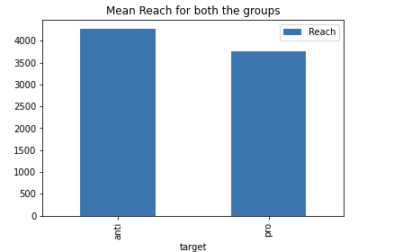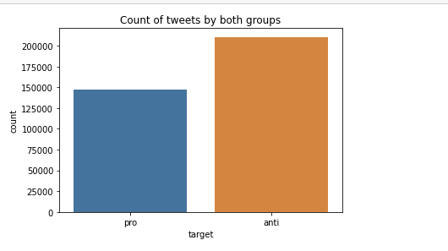

**Fig: Reach of both groups Fig: Count of Tweets made by the groups**

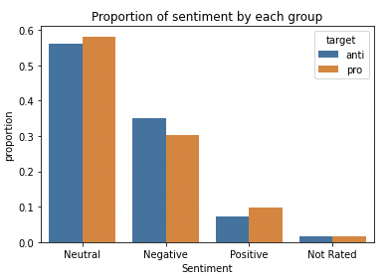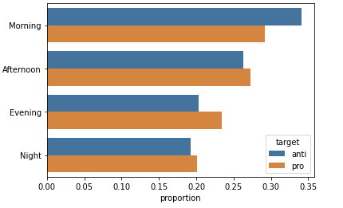

**Fig : Sentiment of the tweets by groups Fig: Time of the day when tweets are made**

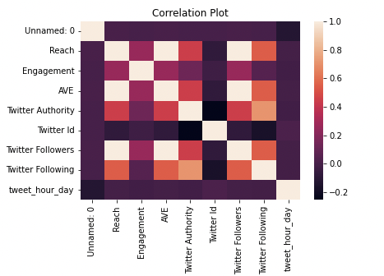

**Fig. Correlation Plot to remove similar columns**

The Correlation plot with 1 being the highest correlation is used to remove variables that provide the same information, in our case Column Reach, Twitter Followers and AVE are the same so we can remove two of these columns. Now that our Data is cleaned

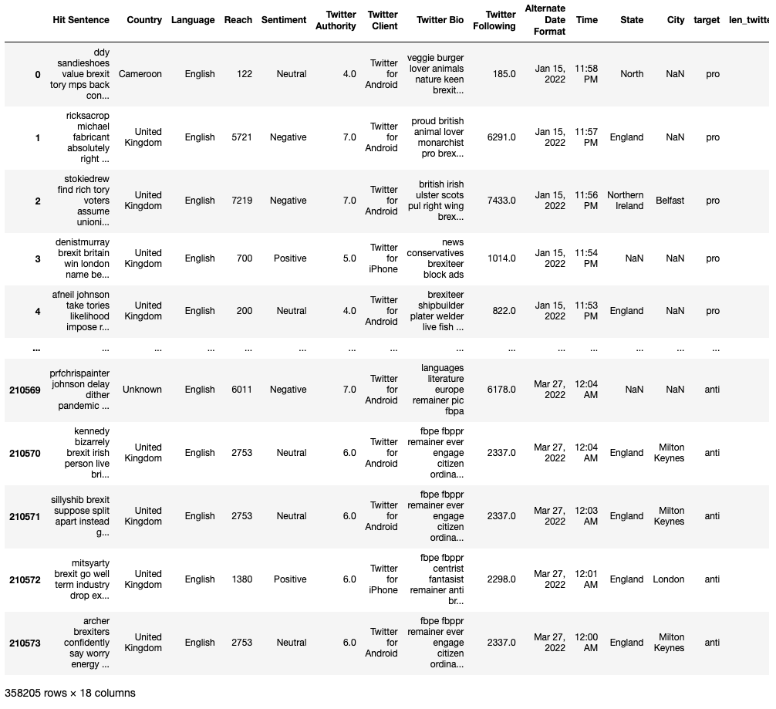

**Fig: Cleaned Data** **Fig: Raw Data**

***Analyses: Association Rule Mining (ARM)***

Association Rule Mining is a kind of unsupervised learning which is used to measure correlations or associations between certain objects. For example Market Basket Analysis. Basically If a person goes to a shopping mall with ARM you can evaluate what he is likely to buy after say buying milk, and you put the next object right next to the milk so that his buying experience improves.

Now the way we calculate these associations is using :

* Support

This basically means that how many times A&B occur together relative to the number of transactions.

Sup(A,B) = (A,B)

(Count of A&B together)/(no. transactions)

* Confidence

Conf(A,B) = P(B|A) = P(A,B)/P(A)

(Count A&B together)/(count of A)

* Lift

Lift (A, B) = P(A, B) / P(A)P(B)

If Lift(A,B) = 1 we say A&B are independent and not associated with each other.

If Lift (A,B) < 1 we say A and B are negatively correlated.

if Lift (A,B) > 1 A and B are positively correlated (And these are the associations we will be looking at).

Now Support refers to how often a given rule appears in the database being mined and Confidence refers to the amount of times a given rule turns out to be true in practice. Lift is used to tell if a certain rule is positively correlated.

Let's start with data. We will only use the text column Hit Sentence here and convert to transaction data.

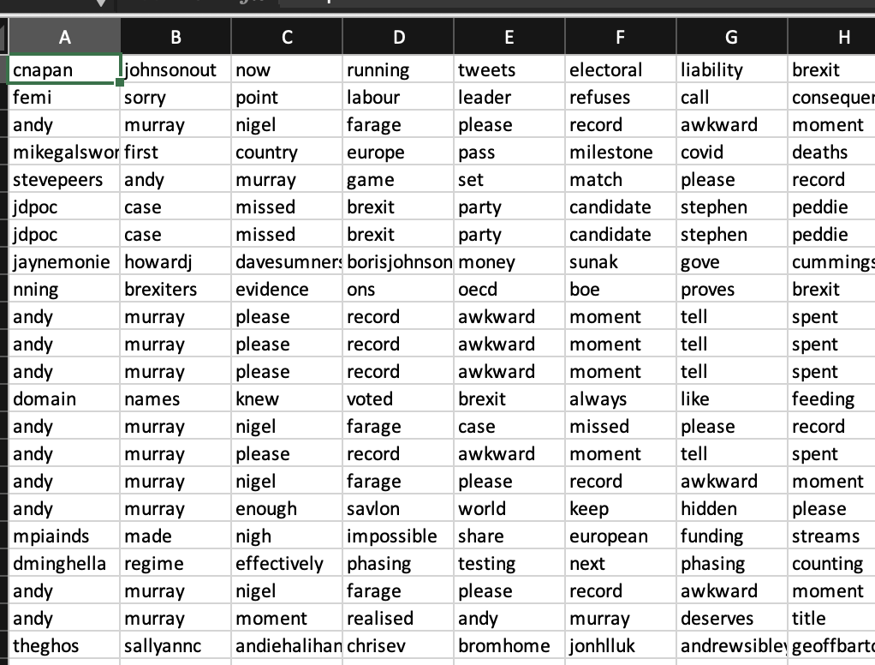

**Before After**

***Analyses: Clustering***

**Kmeans** :

Kmeans is a centroid based clustering algorithm, this algorithm separates the space into K similar clusters using a distance metric, in scikit learn implementation it only uses Eucledian Distance.It calculates the clusters in 3 simple steps.

* Pick Initial Cluster Centroids.
* Assign the Clusters.
* Move Centroids.

**DBScan**:

DBSCAN groups together points that are closely packed together while marking others as outliers which lie in the low density regions. DBSCAN starts with an arbitrary point x and identifies points that are within the neighborhood using a distance metric or “eps” (in case of scikit learn). Then depending on the number of min samples required to consider a cluster it will create a cluster around that point. After Creating that cluster, it will try to determine more points that are in the neighborhood and create new density points according to that.

**Hierarchical clustering:**

Agglomerative clustering is a general family of clustering algorithms that build nested clusters by merging data points successively. This hierarchy of clusters can be represented as a tree diagram known as dendrogram. The top of the tree is a single cluster with all data points while the bottom contains individual points. There are multiple methods to link these data points:

* Ward
* Average
* Complete
* Single

So if the dataset has points which are linked to each other like say how similar a certain book is we will use hierarchical clustering, if dataset is noisy and has outliers and require density i.e measuring clusters of populations in a state according to their interests we can use DBSCAN. For measuring longitude and latitude clusters in a city for analyses of restaurant distribution we can use K Means.

***Distance Metrics:***

**Cosine Distance:**

This uses the angle between the vectors to find out the similarity between the two of them, highly useful in image and text data of very high dimensionality.

**Euclidean Distance:**

Euclidean Distance is used when you need to measure distances and the magnitude of the values matter, you don’t care about the magnitude in cosine distance. Euclidean distance is also the shortest distance between two points.

**Manhattan Distance:**

Manhattan Distance is the sum of all real distances between two points, so if there are a lot of different variables with different scale in the dataset such as (age, gender, weight etc) we should use manhattan distance and not the euclidean distance.

For Clustering we will use the same text column and convert it to a tfidf sparse matrix using this line of code we will only use 20000 rows because it takes a lot of time for clusters to process the huge text data.

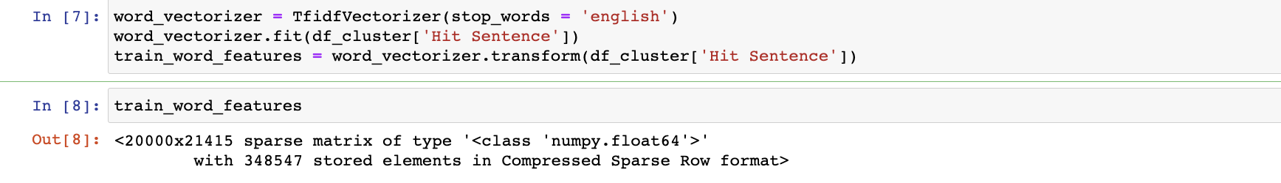

***Analyses: SVM***

SVM are a type of Supervised Machine learning algorithms whose objective is to find a hyperplane in a N dimensional space.

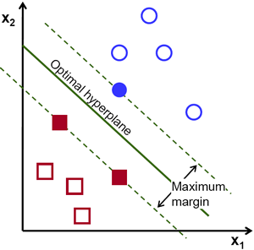

There are an infinite number of ways to imagine this hyperplane , we can do this in 2D ,3D, 4D etc.

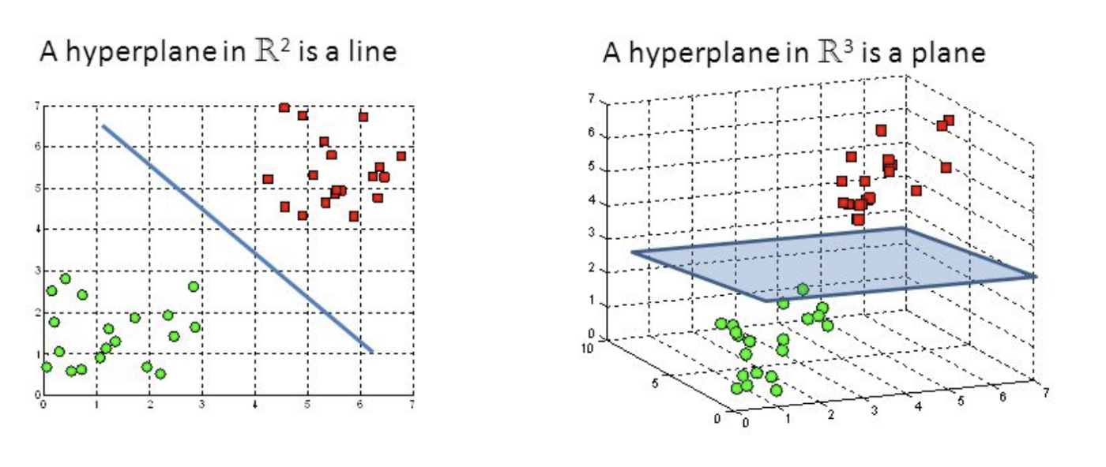

SVM initially was a linear algorithm only worked on datasets that were linearly separable, but with the addition of kernel trick it started working well with Non Linear datasets too. The kernel trick in question was invention of Kernels such as RBF that worked really well with non linear datasets,

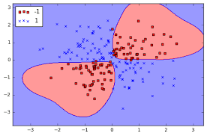

**SVM WITH RBF KERNEL**

For analyses of with SVM ,Decision Trees and Naive bayes we use the same cleaned text data we used for K means. With 20000 Rows of text data and target as pro or anti and our goal will be to classify this using these algorithms and see the F1_Score.

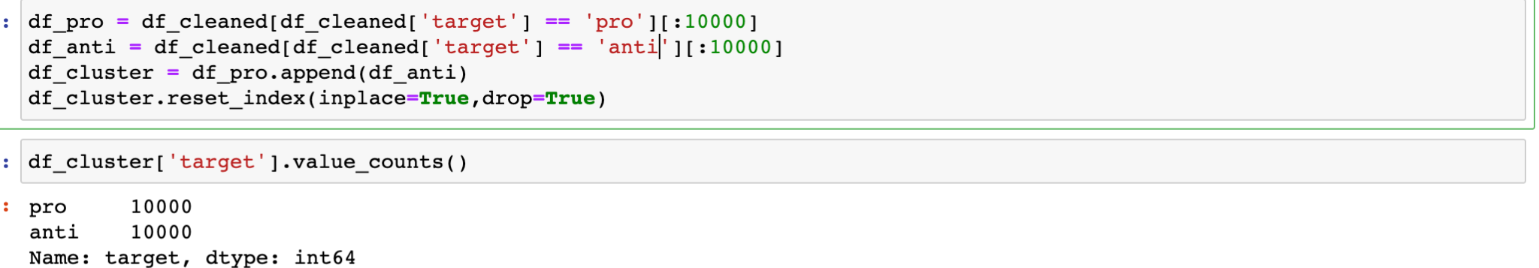

This is how we separate test and train data, we use a parameter called stratify(equal distribution in train and test) this data will be used in all the algorithms basically svm, decision trees and Naive bayes to do predictive modelling.



We fit the tfidf vector on train and transform test too with that , this is a highly necessary step, why tfidf because machine learning algorithms need numeric data to do the analyses. So tfidf will convert our cleaned tweets into a sparse tfidf matrix . We will do the same in R. The using these matrices will be fit and predict.

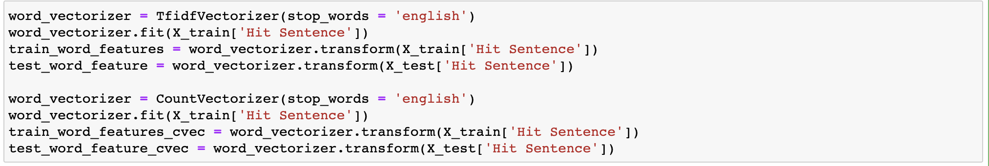

Shape of new test and train dataframes.

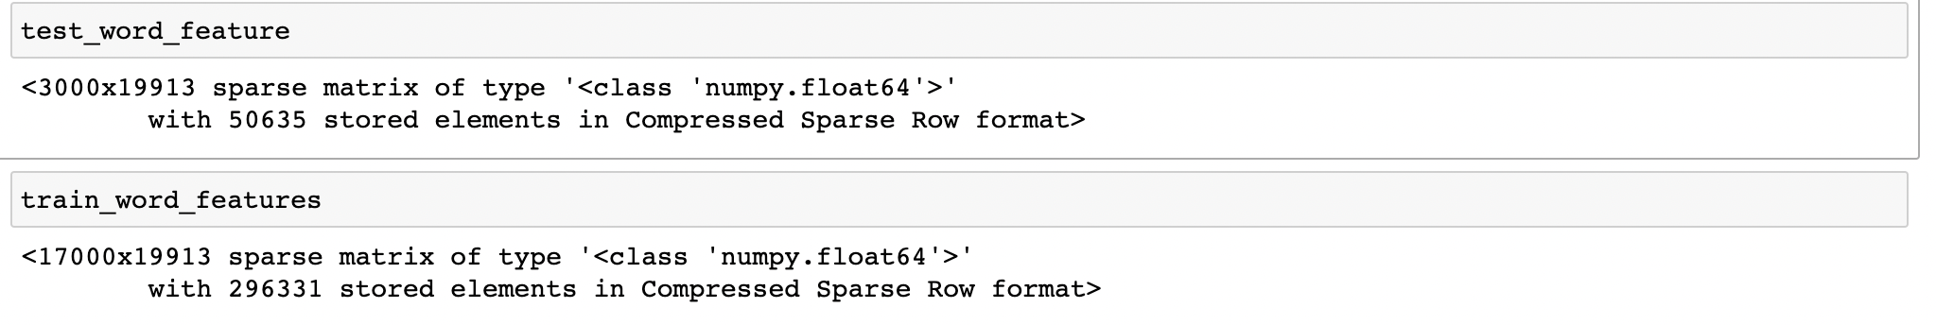

Prediction with Kernel RBF and C=1.0



Prediction with Kernel Poly and C=0.8

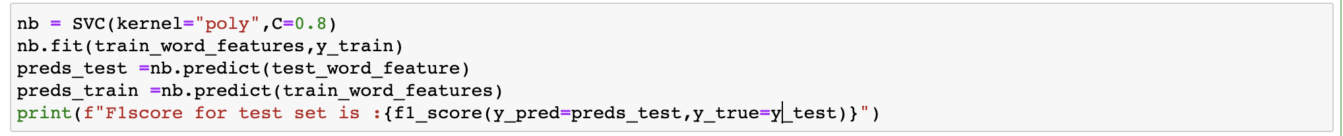

Prediction with Kernel Linear and C=1.4

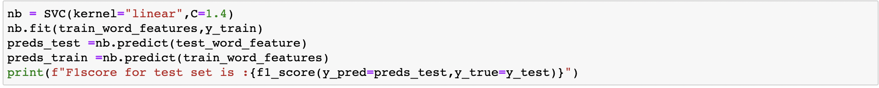

***Analyses: Naive Bayes***

Naive Bayes is a probabilistic supervised machine learning model that is used to discern different objects based on their features.

It is used for classification tasks and at the crux of this model is the bayes theorem

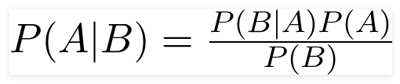

We here in our case are using Multinomial Naive Bayes , this is known to have a really good performance classifying text documents or just documents.

**Naive Bayes in Python:**

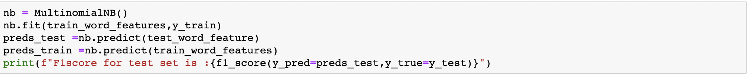

**Naive Bayes in R:**

For Naive bayes in R first we take only a subset of data i.e only 4000 rows 2000 anti tweets and 2000 pro tweets, we will also use this data for decision trees in R.



Split the data into test and train, createPartition function is a part of the caret package in R, this also stratifies the data by default really useful.



Converting the text column Sentence to tfidf vector in R using text2vec package in R, we will fit on train data and then transform train data and also the test data.

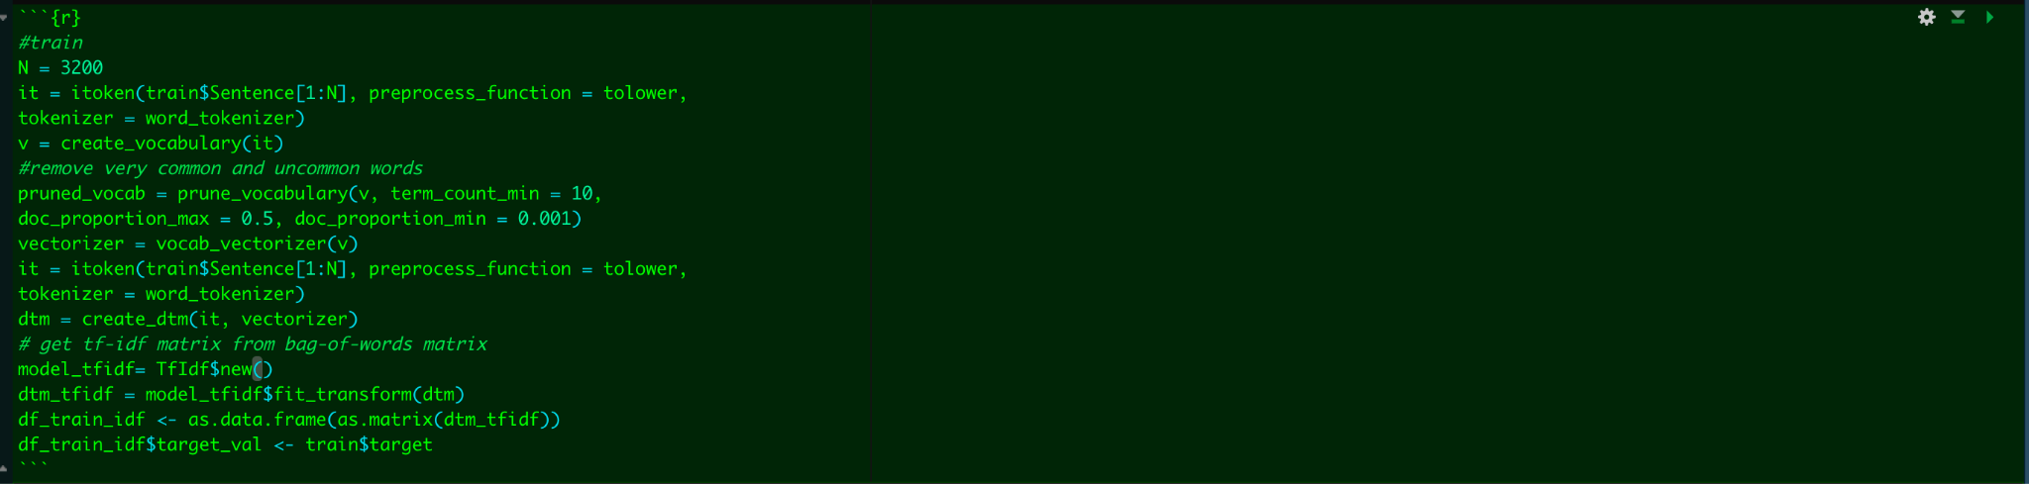

Here is the dataframe of the converted tfidf, the data has both discrete and continuous variables.

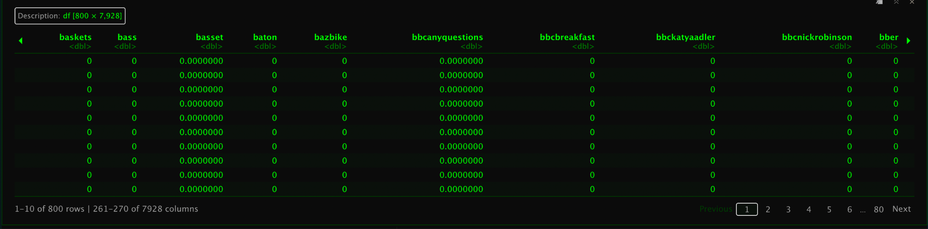

Fit the Naive Bayes model without using the gaussian kernel

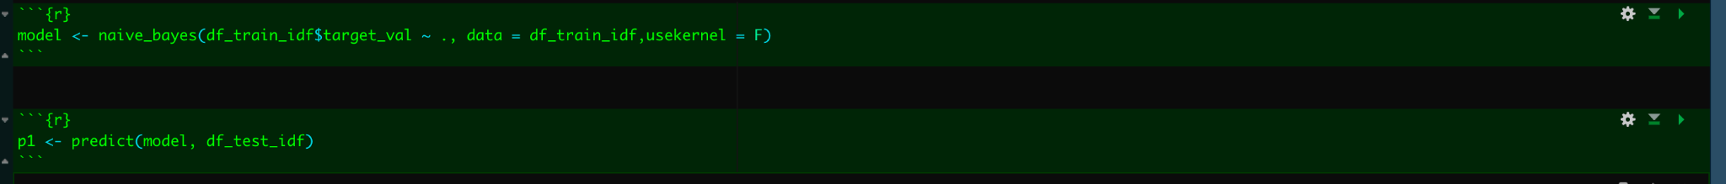

***Analyses: Decision Trees***

Decision Tree is a supervised learning algorithm which uses a set of rules to make decisions, i.e if Age > 80 predict 1 else predict 0. Unlike a probabilistic model such as naive bayes it learns this rules from historical data and tries to predict the future data. How does it find these rules? Well, it uses something called gini , entropy and information gain to find these rules and then apply them on the unseen data.

**Decision Tree**

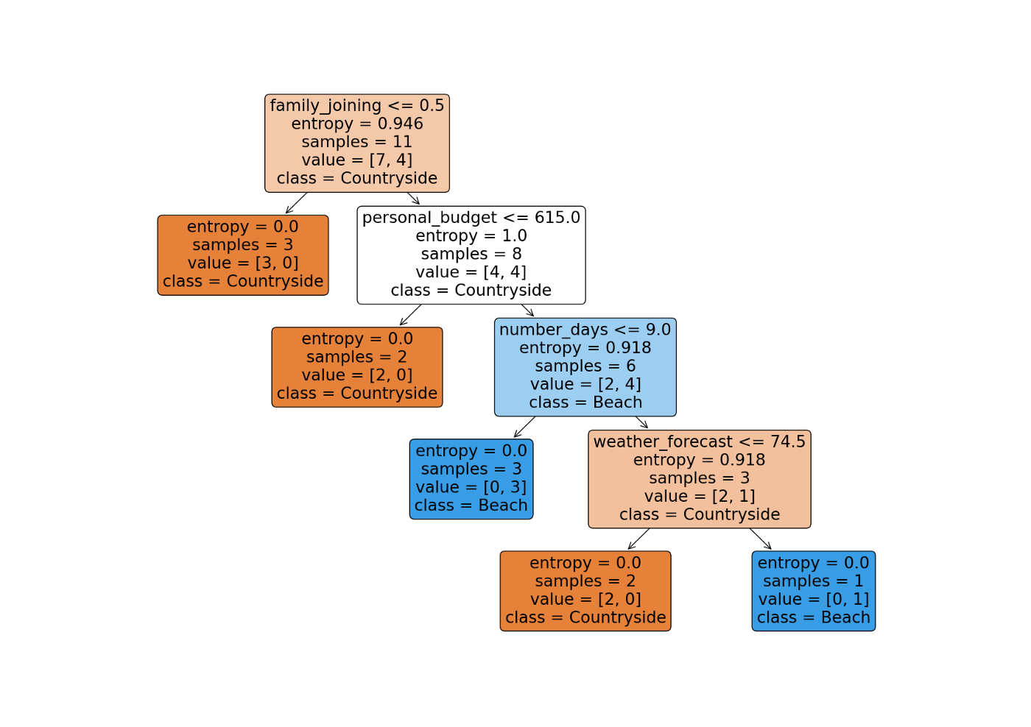

**Entropy** is the measurement of impurity or randomness in the data, value lies between 0 and 1.

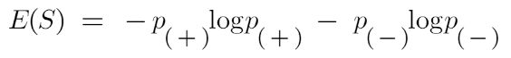

**Information Gain is** basically entropy of the given full dataset - the entropy of the dataset given one feature.

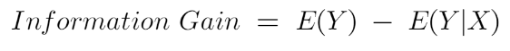

**Gini** tells us about how impure a node is , i.e if the gini value is low then we keep that node, it only creates binary splits and Value lies between 0 and 0.5.

Gini Index= 1- ∑jPj2

Computationally Entropy is slower than gini because it calculates the log at each step, gini is way faster in these regards.

**Decision Tree in Python with Gini as criterion**

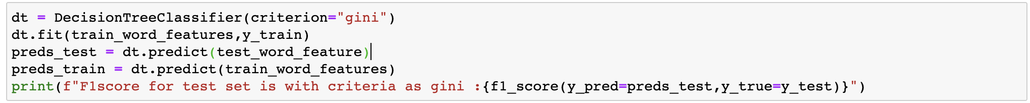

**Decision tree in Python with Entropy as Criterion**



**Decision tree in R**

For R we use the same data as we used for naive bayes to calculate the scores and the confusion matrix.



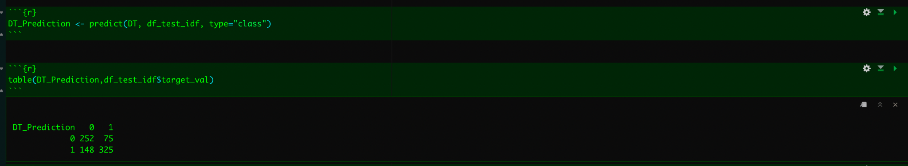

***Analyses: Neural Nets***

Neural Networks or also known as Artificial Neural Networks are algorithms that mimic a human brain, similar to a human brain we have something called several neurons that are connected to each other. Similar to our brain’s neurons which are activated using electric impulses, these artificial neurons are activated by an activation function such as (sigmoid, tanh , Relu) etc. Neural networks are probably the greatest invention of modern times, they have shown excellent results in classifying images and textual data even better than humans.

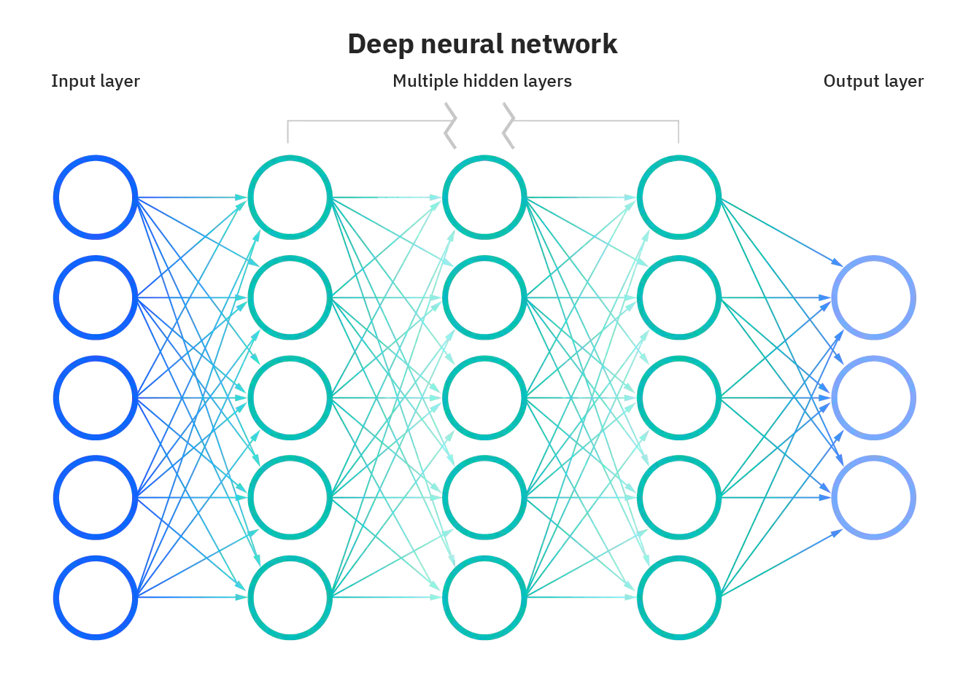

**Deep neural network**

A neural network consists of an input layer, a hidden layer and an output layer; these types of neural nets are called a perceptron. When a neural network consists of many hidden layers with a huge number of neurons we call this a deep neural network as shown in the image above. Neural networks consist of three parts: input layer , hidden layer and Output layer. The input layer basically is just the input provided to the hidden layer, every input layer has what we call a node which is basically a linear regression function.  
  
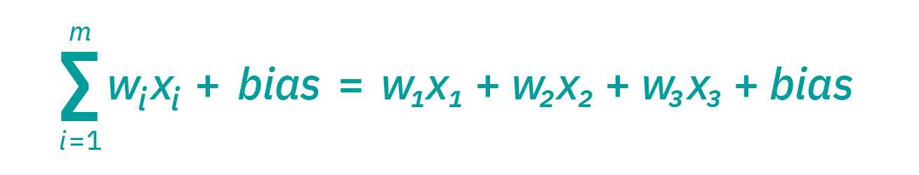

**Node Equation**

All of these nodes have a certain weight and a bias associated to it, we input the data through this layer and send it to the hidden layer. Every node in the hidden layer has something called an activation function. These activation functions like sigmoid , tanh, relu etc. , they activate the node in the hidden layer. These functions essentially add non linearity to the neural network which helps in analyzing non linear relationships and makes neural networks really useful. The output of the hidden layer is sent to the output layer, this whole process is called as the feed forward part of the neural network. Now at the output layer we calculate the loss i.e real - predicted and try to reduce this loss.

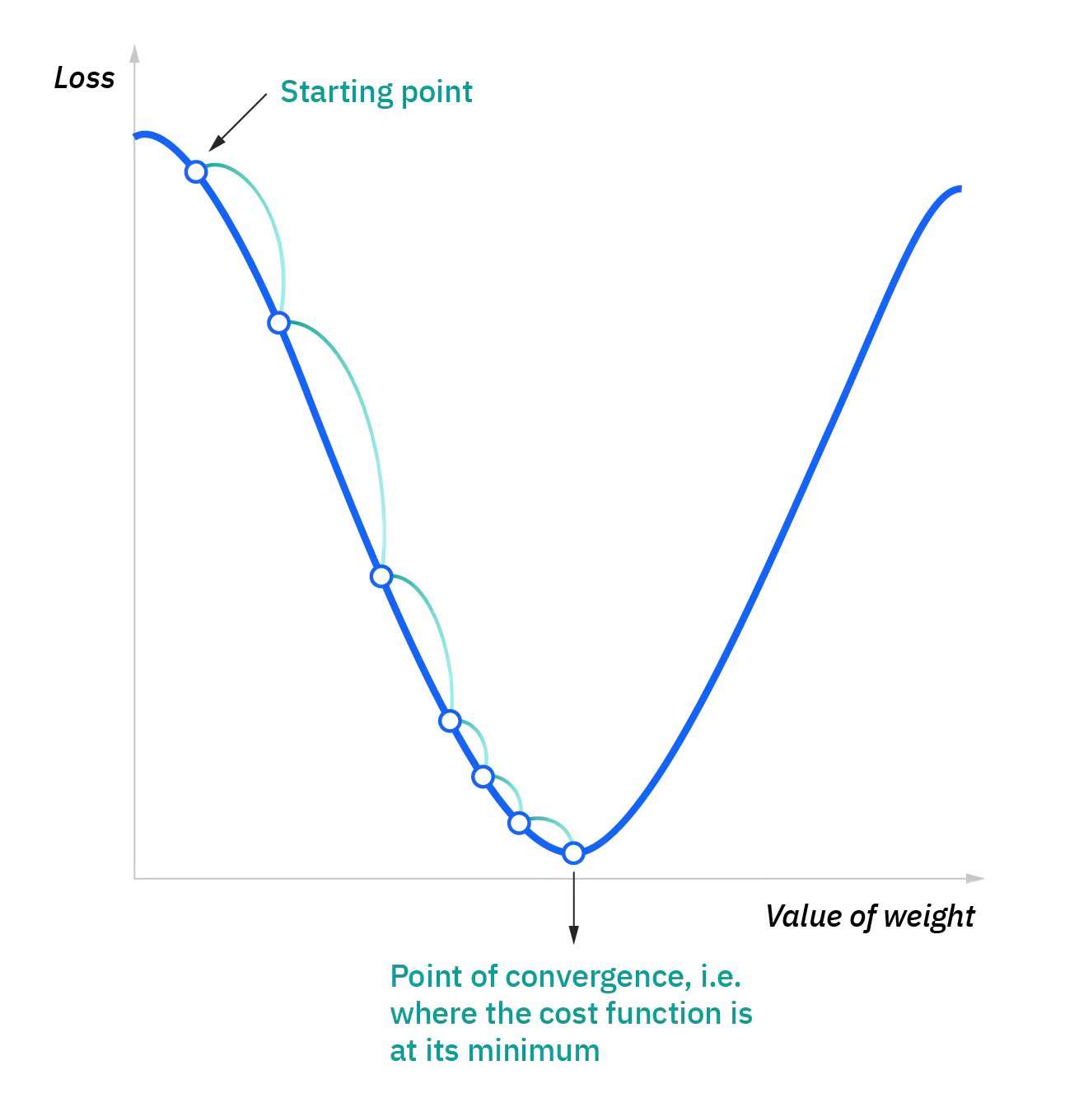

**Convex function**

We now will go back to the input layer , and try to minimize the loss. The cost functions in our case are all convex so to reach the minimum we use an algorithm called backpropagation where we will try to find the derivative of the cost function to minimize the loss and update the weights at each node. We will also use something called a learning rate to update the weights, learning rate helps reduce the steps taken to reach the minima. High learning rate might lead to overshooting the minima i.e never reaching it. Very low learning rate will lead to very small steps and we might never reach the minimum or it will take a long time to reach it, so learning rate is really important.

There are different types of neural networks and they all work differently on different datasets (i.e no lunch free theorem) . CNN’s or convolutional neural networks work the best on image data, LSTM or Long Short Term Memory Networks work really well on sequential data i.e next word recommendation, DNA seq prediction etc.

**Results:**

Now in our dataset we had a lot of data that was redundant and also text data which we needed to preprocess. This dataset helps us to understand how pro and anti brexit groups influence the brexit decision. So people with more power and reach on twitter can sway the public opinion which can lead to election manipulations. So it's highly imperative that this analysis be done. For Example let's take a look at the sentiment analysis of the tweets by both the groups. Now if you look at the graph you can see that I have used Proportions instead of absolute values. This is because there are more tweets by anti brexit people then pro brexit people, this helps to quantify things in a better way.



The graph above shows that pro brexit people have tweets that have more positive sentiment than anti brexit people and Anti brexit group seems to be more violent as they have more negative tweets than pro brexit group. Now Analysis like this could help the police and the government agencies to keep the peace.

***ARM RESULTS:***

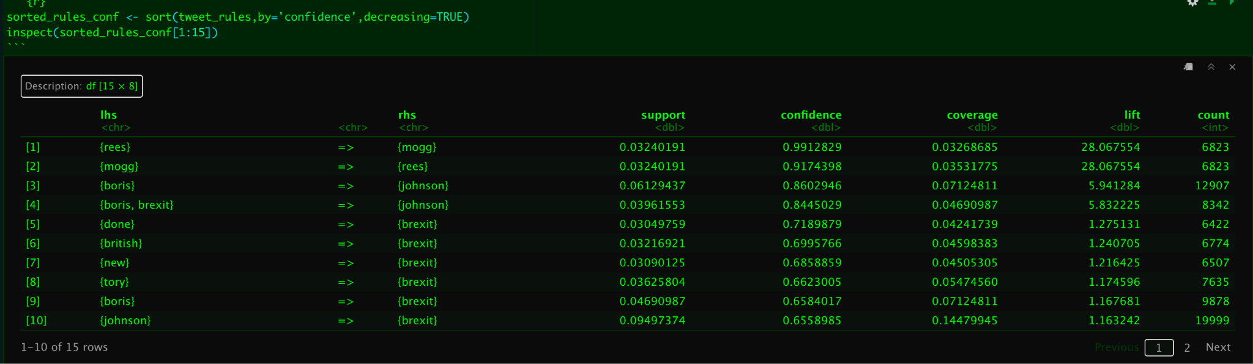

The above fig is sorted by confidence, now confidence tells us that how confident the algorithm is in telling if rees is going come after mogg and vice versa. This is a great metric to decide the probability of reece -> mogg is 0.99.

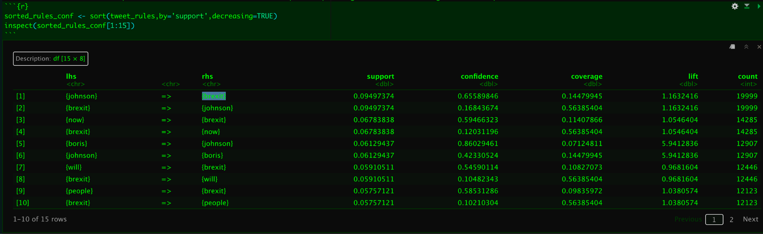

The above fig is sorted by support, which basically means how many times a certain rule has occurred compared to the number of transactions.In our case its boris johnson, considering he was the prime minister at the time so its highly likely people will mention him in all the tweets, so really not a good rule.

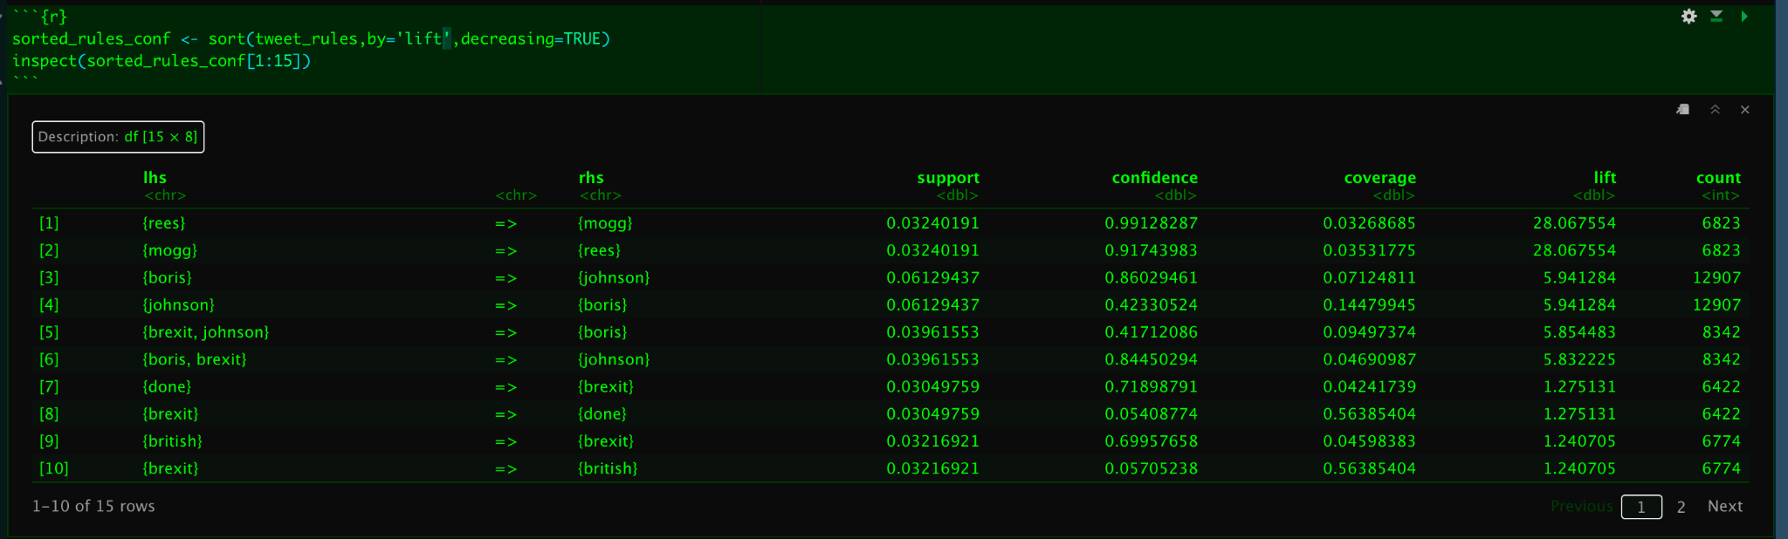

The above fig tells us the top 15 rules sorted by lift , lift basically tells us which rules are basically important in our dataset , in our case rees mog is highly associated rule, lift can be used to compare confidence with expected confidence.

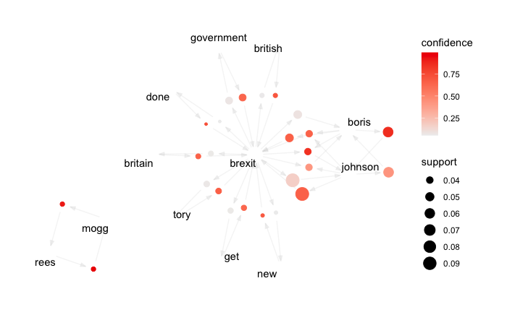

***Network graph of Rules Sorted by Lift.***

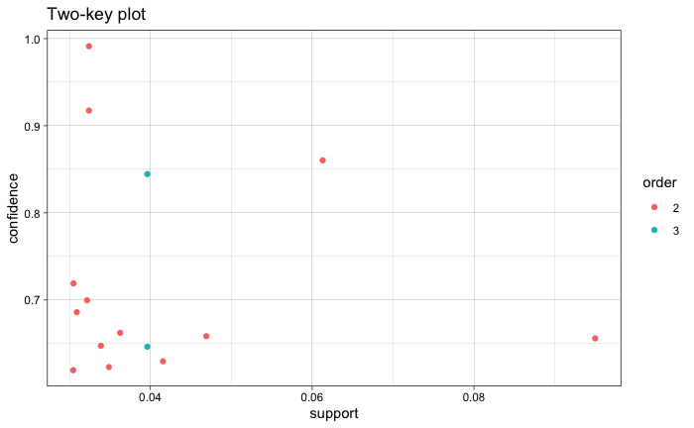

***CLUSTERING RESULTS:***

So we compare the results of the clustering algorithms with the target variable separation as shown below, we use tf idf vectors and reduce its dimensionality using truncated svd to plot this. This is the distribution that we might expect if the clustering algorithm works properly.

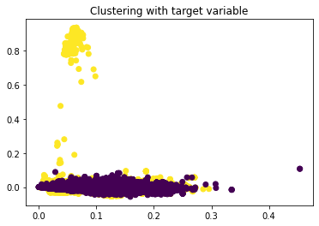

**K MEANS:**

For K means we use the elbow method to get the best values of K so we chose K=2, which closely resembles the graph above with the true variables. For K =3 and K = 4 the observations are really not great.

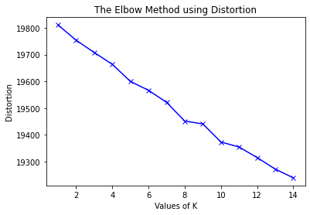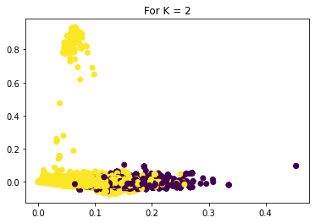

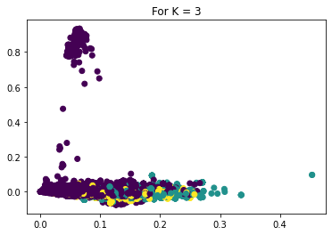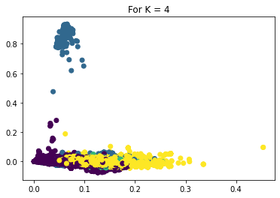

**DBSCAN:**

This works the worst on this data we get multiple clusters even after trying to play with parameters “eps” and “min samples”, this doesn’t really work well with the data we are using,

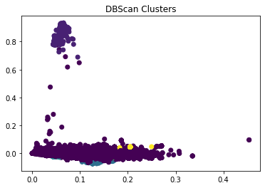

**Hierarchical Clustering:**

We use three separate metrics for hierarchical clustering Euclidean, Manhattan and Cosine, Euclidean performs the best while Cosine performs the worst.

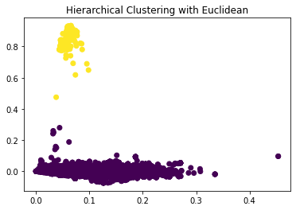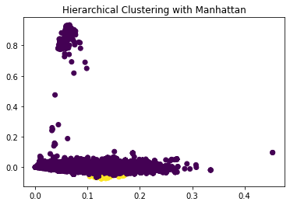

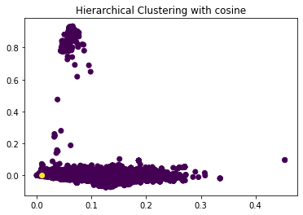

Kmeans is the best performing clustering algorithm of all because it creates the clusters resembling the true values of the data. I.e it is somewhat able to classify tweets as anti and Pro brexit with the tf idf vectors created. This is very useful since we can now easily target the groups in the cluster, if there is something like this in the future.

**SVM:**

Here in SVMs we included three different kernels and different cost values associated with them, the results were surprising to say the least:

SVM(Kernel: RBF , Cost = 1.0):

F1_score for test set is : 0.9158069883527453

SVM(Kernel: Poly, Cost = 0.8):

F1_score for test set is : 0.8428899082568807

SVM(Kernel: Linear, Cost = 1.4):

F1_score for test set is : 0.911170928667564

And below are the confusion matrices for all of these, unsurprisingly RBF the non linear kernel performs the best with the default settings but surprisingly Linear kernel is the second best with a little bit of tuning and Polynomial the third. Running a svm with a linear kernel seems to be a really good choice on the dataset as it will run faster with almost the same f1_score.

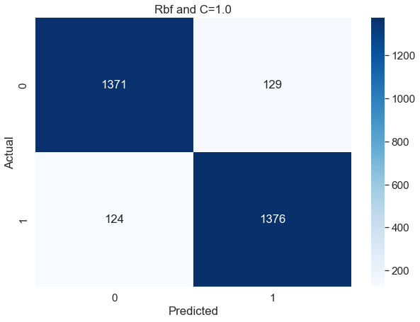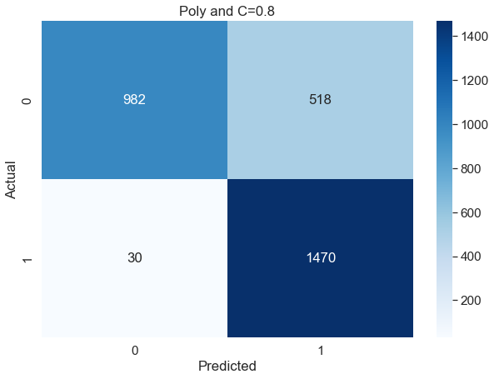

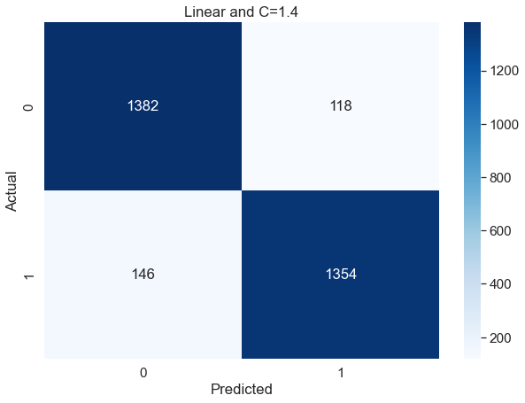

**Decision Trees:**

There were 3 Decision trees trained for this 2 in python with criterion as Gini and Entropy respectively and for R it was just the baseline decision trees. The data used was also Just the tfidf vectors.

The F1_score on test set for decision trees in python with criterion as Gini : 0.8566587597424601

The F1_score on test set for decision trees in python with criterion as Entropy: 0.851465139777703

The F1_score on test set for decision trees in R : 0.69326

The decision tree with gini as the criterion works the best, again the R decision tree seems to reduce in f1_score now it seems to because of the subset of dataset used , the dataset just consists of 4000 Rows with 50% anti and 50% Pro tweets, same as the one used on naive bayes. The consistency in both naive bayes and Decision tree results seems to confirm that because of the length of the dataset we might be getting a very low f1_score. For instance in python we are using 20000 rows with similar distribution. Tfidf vector also consists of discrete and continuous data and decision trees love really well with both the type of data because in the end it just makes rules . We learned from this that decision trees don’t require standardization of the data and can work well with discrete or continuous data .

**Confusion Matrix with Python:**

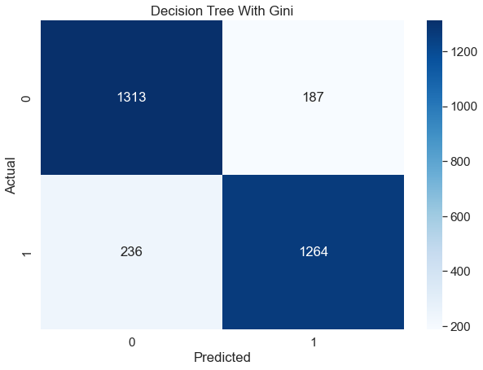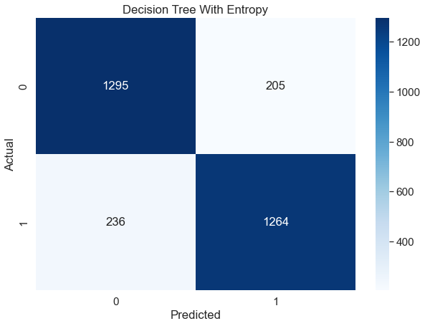

**Confusion matrix in R:**

**DT_Prediction 0 1**

**0 252 75**

**1 148 325**

**Naive Bayes:**

For Naive Bayes in R and in python we used the same tfidf vectors, one was created in R and the other was created in python with very different and surprising results.

For Naive Bayes in Python we used Multinomial Naive Bayes with count data

The F1_Score on test set for this : 0.8983957219251337

For Naive Bayes in R we used normal naive bayes with Poisson and Gaussian kernels both as false the result is not good but we also used only quarter of the data we used in python due to memory issues

The F1_Score on test set for this : 0.3855422

The Multinomial naive bayes works the best as you can see with the F1_score , if we use the gaussian kernel in R the f1_Score increases to 0.665 but when we see the confusion matrix it seems to only predict the 0s and not the 1s. Will need to research more on this but the difference in results is huge, it could be because of the small dataset we have used, or maybe because of the normalization done by naive bayes in R.

**Confusion matrix in Python for Naive Bayes:**

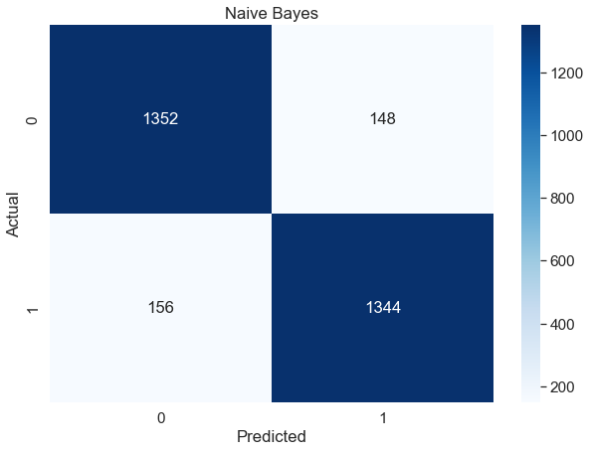

**Confusion matrix in R for naive bayes:**

p1 0 1

0 128 136

1 272 264

The best performing model was the SVM with RBF kernel and the default cost function of 1.0 now which makes sense , text data inherently is complex and require non linear algorithms to classify the text data the best. SVM with linear kernel was 2nd best followed by NaiveBayes(Multinomial). Naive Bayes was very obvious because its known to be used in classification of text documents and its working really well here. Surprisingly SVM with linear kernel performs really well too.That really shows how good SVMs really are.

**Neural Network:**

We createda neural network using Keras, and trained the neural network with batch size 128 and 10 epochs,

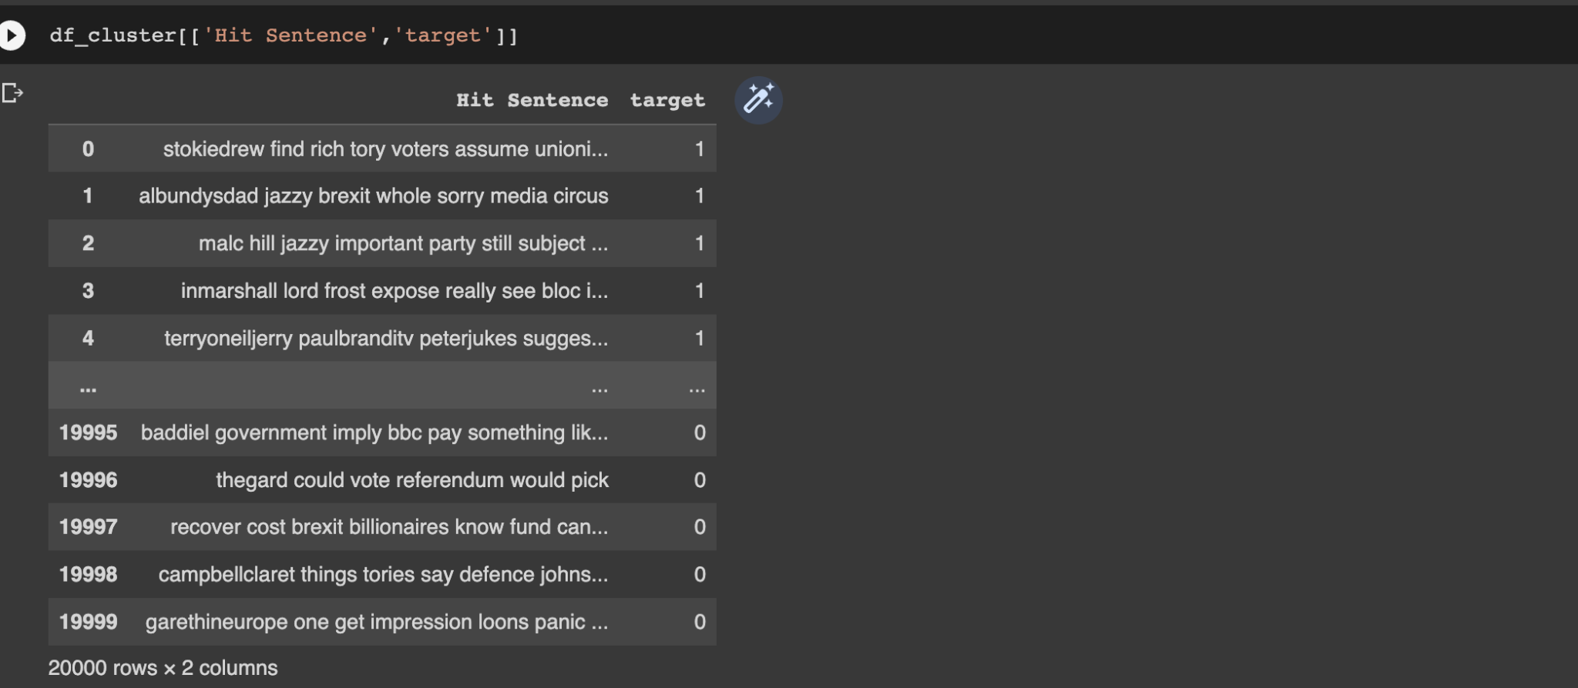

**Input Data**

This is our dataset, target being the column that is the label with 1 or 0 as value and hit sentence is the sentence to be classified. We can actually give the text data directly to the neural network if we want to but for that we have to use a different architecture such as a LSTM, in our case we are using a basic sequential neural network. Therefore we need to convert this text to numbers so we will use Glove Embeddings and convert this text data to numbers using that.

This is the embedding matrix we get, its shape is (20049,100), so that also should be the shape of our neural network input layer. 20049 is basically the vocab size and 100 is basically the representation of that vocabulary in numbers. Output layer should be either 1 or 0 .

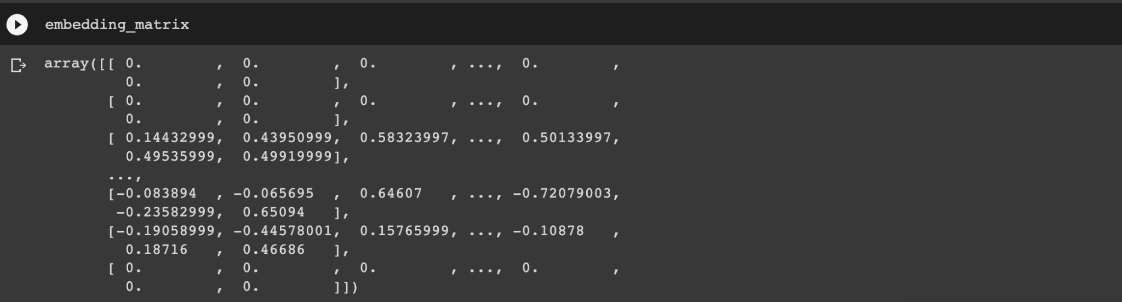

**Embedding Matrix as training Input**

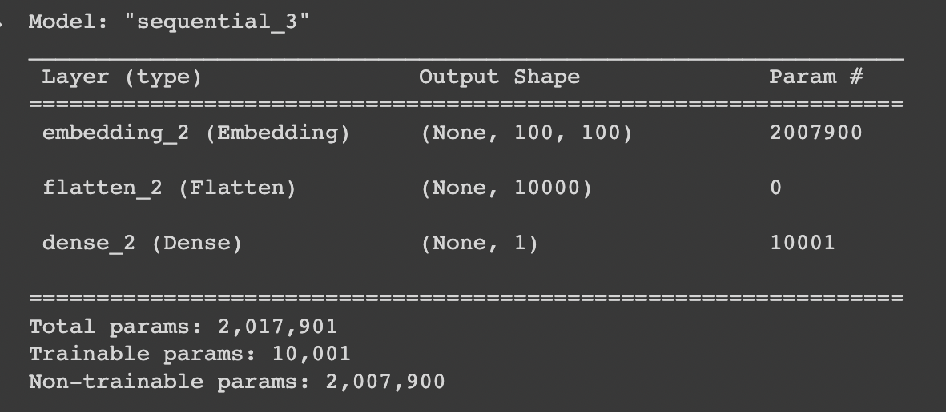

**Neural network**

This is how our neural network looks like, we will be using binary cross-entropy as our loss function because our output needs to be 0 or 1.

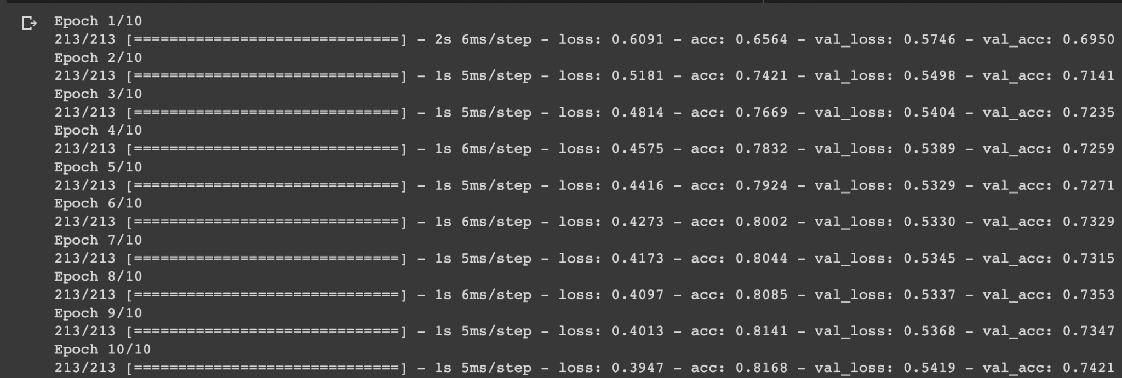

**Training**

So we can see the model doesn’t really seem to generalize really well on unseen data, this is because neural networks require large amounts of data to generalize and train well. In our case we have only 20000 rows of text data which is very less. But still the performance seems to be okay.

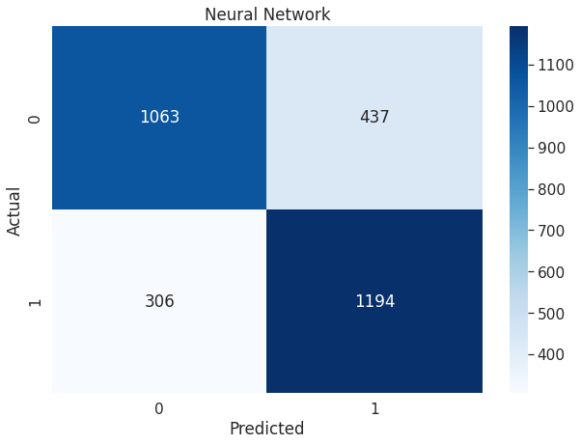

**Confusion Matrix**

We get an accuracy of 75% on our validation data after 10 epochs, which when compared to our other models like Multinomial Naive Bayes (89%) is very less. To increase the accuracy we can increase the size of data, use much larger embeddings i.e Glove has a model which produces embeddings of size 300. Use a custom LSTM architecture which can create its own embeddings inside the neural network (This requires huge amounts of data and training time) . This has much better performance. Use a pre-trained State of the art transformer model.

**Conclusion:**

The tweets by anti and pro brexit groups data helps to analyze the behavior of people following a certain political ideology. We can use this data to check if the tweets made by these groups are actively trying to sway the government decision on a certain policy or not. Nowadays Social Media sites like twitter are used in very different ways to influence government policies, start a revolution and cause public disturbances. So this could help identify these behaviors.

Analyzing this data using different techniques such as ARM and Clustering helps us get more information about the behavior of people who participate in political contests. It's highly imperative to study this as this could shape a country’s future, in our case the United Kingdom. Brexit will have a very high impact on the British population but also the European population as it means Britain will exit the European union. Since the UK is a democracy , and we are living in a world that's online all day, these tweets can help us maintain peace in the future for these political discourses.

Clustering can help us find separate people who support an agenda or the ones who don’t from twitter, they can also be subdivided into sentiments, groups that can turn violent, affinity to commit crimes, geolocations etc. It can also help us identify bot behavior that can be used to influence the decisions of a political party.



ARM can be used to actually determine bot behavior much better since it finds out association of different words with each other we can find out who are these people talking about , who is the most pressure on in the government, for ex in our dataset when we analyze using ARM we find out boris johnson(Prev Prime minister of the uk) and reese mog(secretary of state) are the most talked about people, and since its a brexit data people are talking a lot about brexit. So one of the applications could be, In real time we can do this analysis easily and create rules such as if boris johnson occurs in a sentence mute that tweet from my timeline.



The supervised learning algorithms can help us predict the future behavior of tweets such as anti and pro brexit, it can also help us to classify tweets based on their sentiments. Sentimental analysis of the tweets could help reduce violence , by taking affirmative action in real time. NLP is really imperative in today's time as people are online most of the time, so if we can analyze the way they write texts on social media apps can help us a lot with policing, drug trafficking , political violence , racial hate etc. Supervised algorithms can analyze this data and help us a lot. We can also use algorithms such as transformers to analyze text data and predict sentiments. Google uses such large language models to improve its google search, and with new models such as ChatGPT 3 with over 100 billion parameters can even perform better than humans, write code , write poems etc.